1300 North 17th Street, Suite 900
Arlington, VA 22209, USA
+1-703- 475-9217
http://dicom.nema.org
E-mail: dicom@medicalimaging.org

MINUTES

JOINT MEETING OF DICOM WORKING GROUPS TWENTY EIGHT (Physics) and TWO (Projection Radiography and Angiography)

Date: October 28, 2013

Place: DIN Offices
Berlin, Germany

Members Present Represented by
AAPM Donald Peck
EFOMP Annalisa Trianni
Siemens Healthcare Heinz Blendinger
GE Healthcare Francisco Sureda
ACR William Pavlicek (Tcon)

Members absent Representative
Philips Healthcare Revet Bas
Toshiba (JIRA) Makoto Suzuki

Presiding Officers: Donald Peck (AAPM)
Annalisa Trianni (EFOMP)

Secretary: Alberto Torresin (EFOMP)

Opening
- The meeting was called to order at 10.15.
- Participants identified themselves and their employments. A quorum was present
- Members reviewed the anti-trust rules.
- Members reviewed the agenda that was accepted as such.
- The minutes from the meeting of March 2013,8 Vienna (AT) (see document WG-28-2013-03-08-Min.docx) has been reviewed and approved.

Joint AAPM/EFOMP White Paper on Patient Dose determination from radiation exposures during diagnostic and interventional studies
A Tcon took place from 2 pm to 4 pm, Berlin time, to review the structure of the White Paper on patient dose estimation from CT and Fluoroscopic imaging developed by the AAPM TG246 (51 members include AAPM, EFOMP, FDA, GE, Siemens, Philips, MITA) coordinated by Bill Pavlicek. In particular In particular Appendix B for Fluoro (TG246 Appendix B CT Berlin.docx) and CT (TG246 Appendix B Fluoro - Berlin.docx) that lists some suggestion for the extension of the RDSR.)

WG-02 Projection X-Ray joint discussion
Members did not discuss the 3D-CArms with Volumetric Capability and Cone Beam 3D for radiotherapy during this meeting. Refer to the minutes of DICOM WG02 , October 2013, 29-30)

Review Dose SR extensions and potential requirments for Patient Dose SR
Members will work on the structure and requirements to create the new supplement for the creation of a Patient Dose SR containing the calculation of the organ dose (including distribution over the patient skin in interventional procedures).
In particular the following TID schema v2 was discussed and a method of developing the Supplement structure using a “fault tolerance” diagram was created.
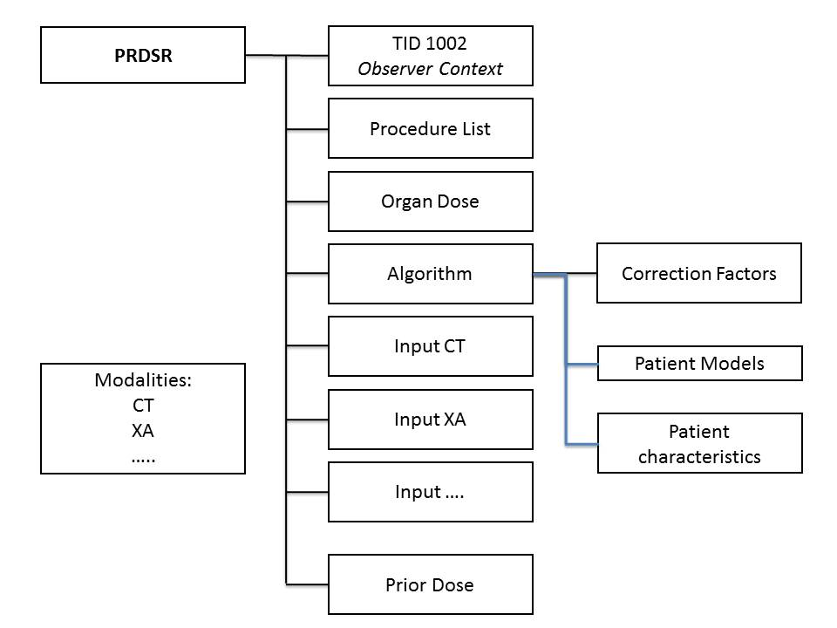

CP and Supp Review
No new CP and Supplements at this time.

Operator Dose SR Work Item
Members received a request from a manufacturer to evaluate an Operator RDSR. Members will contact other companies providing personnel dosimetry to understand if there’s any interest in creating this DICOM object. An official call to DICOM Community for participation will be sent.

Next Meetings
- December 3, 2013 (RSNA) in Chicago, IL. McCormick Place Room W475A.
- March (ECR) in Vienna (AU) , followed by WG02
- May (SIIM) in Long Beach, joint meeting with WG02
- August-October in Europe, TBD
- December, RSNA

New Business
No new business.

Adjournment
The meeting was adjourned at 17.15 on October, 28.

Reported by: Alberto Torresin

Reviewed by legal counsel: CRS 2013-11-04

